**Sabrina Alves**

**Data Science Bootcamp, Kickstarter Analysis**

This analysis looks at 4,000 Kickstarter projects to discover a trick for finding success in the campaign. The information available is each campaign by name, blurb, goal, pledged amount, state of the campaign (successful, canceled, live, or failed), the country is which the campaign is from, the dates of when the campaign was open, the number of backers and the category and subcategory of the campaign. With this data, it can be said that successful campaigns (in general, not by country) more often:

* Fall under the film & video (documentary, shorts and television categories), music (indie rock and rock especially, followed by classical, electronic, metal and pop), and theater (with plays have the most success under this category)
* Happen during the beginning of the year
* Have a goal of $9,999 or less (roughly 74.8% of successful campaigns fall under this range)

We can conclude that film & video, music and theater are the most successful campaigns by calculating the % of grand total of campaigns they have. In Figure 1, a screenshot of the pivot table made to derive this data shows that these three categories are at least 60% more likely to succeed than fail and make up 40% of all successful campaigns. Further, in Figure 2 we can see that certain subcategories make up most of the success under each category. For example, 16% of all successful campaigns, which is roughly 80% of successful theater campaigns, fall under the “plays” subcategory. This information is from a pivot table made from finding the % of grand total for each of the states, sorted by category and subcategory.

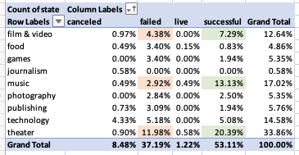

*Figure 1: Summary of Categories and State*

*Figure 2: Success and Fail Rate of each subcategory (all countries)*

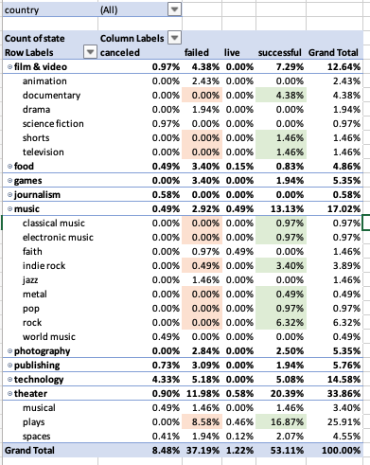

Next, successful campaigns tend to be created/opened in the beginning half of the year, year to year. By creating a time series pivot chart (Figure 3) on the states of campaigns, sorted (rows) by the month of the date created date, and then filtered to show the three most successful parent categories (film & video, music, and theater), we can see the success rate peak by May and gradually fall for the rest of the year. Conversely, the fail rate peaks in June/July.

Figure 3: Time Series Graph of Film & Movie, Music, and Theater

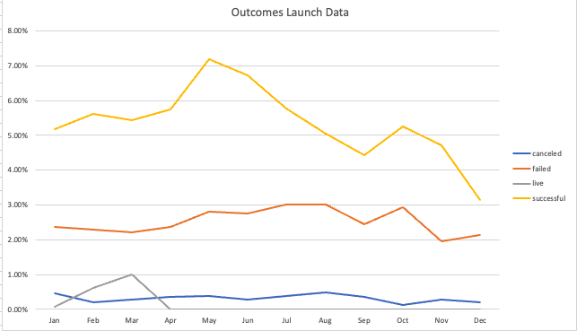

Last, successful campaigns tend to have goals of $9,999 or less, with that range making up about 74.8% of all successful campaigns. To find this out, I used the COUNTIFS function to find the count of the number of successful campaigns that had goals less than $1,000, goals from $1,000 to $4,999 and goals from $5,000 to $9,999. The number of successful campaigns in each of these ranges are 322, 932, and 381, respectively.

Another possible avenue to look at to find tricks to successful campaigns are tables calculating the mean, median, minimum and maximum of the time the campaign spent open for each of the states (successful, live, canceled, and failed). Kickstarter limits campaigns to 60 days and openly recommends a 30-day campaign, but what is best for the category and subcategory of the campaign chosen? A second possible analysis that can be done is finding the mean, median, minimum and maximum of “goal” and “pledged” for the sub-categories. How much is perceived as too much for a project among its peers on Kickstarter, and what would seem to be too little? Are there so many successes because the goals are severely undercutting what the projects needs to be successful? For example, a technology/hardware campaign, id 2734, had a goal of $1 and achieved $22,603. Is this typical for this category, or for the site? Looking into this facet of the campaign would be a valuable piece of information in putting together the trick of a successful campaign.

This analysis attempts to answer the question: What is the trick to a successful campaign on Kickstarter? The available information reviews campaigns only in the bubble of Kickstarter, but the *trick* to a successful campaign may lay elsewhere. This data set should include SEO tags attached to the post and popular trends in the time period of each campaign, the rewards offered to backers, what the company’s social media following prior to the Kickstarter post was, if the company did any marketing for the campaign outside of Kickstarter, if the company posting the project has been successful on the platform and featured on the Spotlight page. Kickstarter projects do not exist in a bubble, and much of the success attributed to these projects may be due to outside forces.

In conclusion, a campaign in film & video (documentary, shorts and television categories), music (indie rock and rock especially), and theater (plays), that takes place in the beginning of the year and has a goal under $9,999 will be most likely to succeed on Kickstarter. To acknowledge the bias in this call to action, this recommendation does not include key campaign strategies that other companies may have used, nor is it specific to a country.

**Bonus Statistical Analysis**

The medians summarize the data more meaningfully. When evaluating what the mean and median of the backers of successful campaigns, it becomes obvious that outliers influence the mean too much to be accurately reflective of the data set. As seen in the figure to the left, the maximum values skew the mean higher than the center range of the data. Additionally, the standard deviation is greater than mean itself, meaning -1 standard deviation is already negative (an impossibility with this data set). The skew in the data means that the mean will not describe most of the data set as the median would.

There is more variability with successful campaigns. This makes sense because unsuccessful campaigns tend to lean towards no attention—meaning no backers at all, or only a few, as the median and minimum attest to in the table above. Alternatively, successful campaigns, which need to achieve or exceed their funding goals, do not receive more consistent treatment on the website. A successful campaign can have only one backer, but it can also have tens of the thousands by the time the campaign closes (far more than an unsuccessful campaign).

**References**

<https://www.howtoexcel.org/tutorials/split-text-by-delimiter/>

<https://www.kickstarter.com/blog/how-to-run-a-kickstarter-film-project-building-your-campaign>